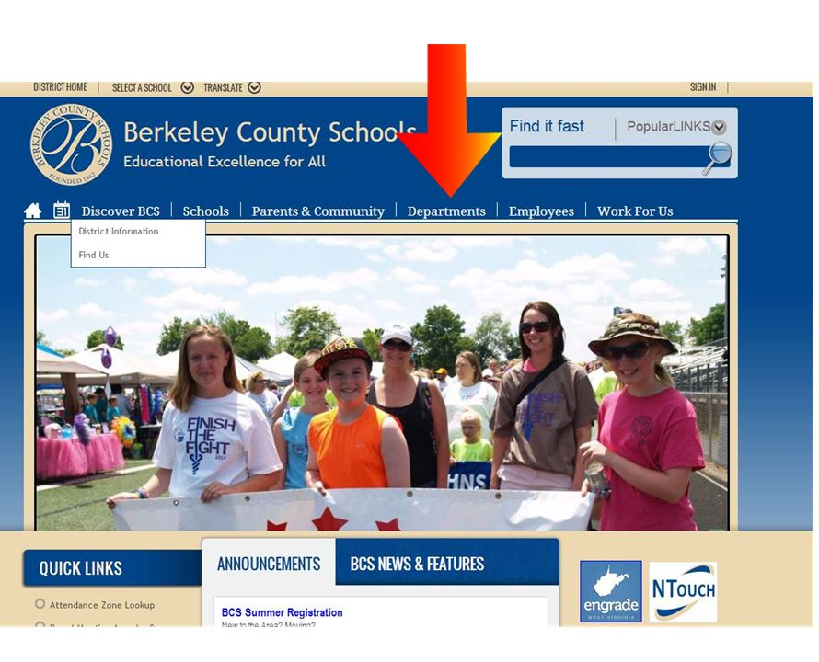

**HOW TO ACCESS STAR REPORTS TO FORM GUIDED READING GROUPS**

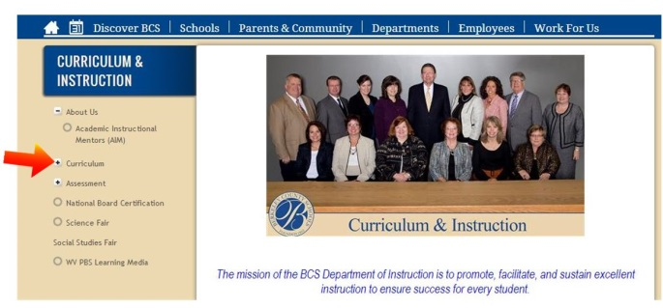1.

**Choose “Departments”**

2.

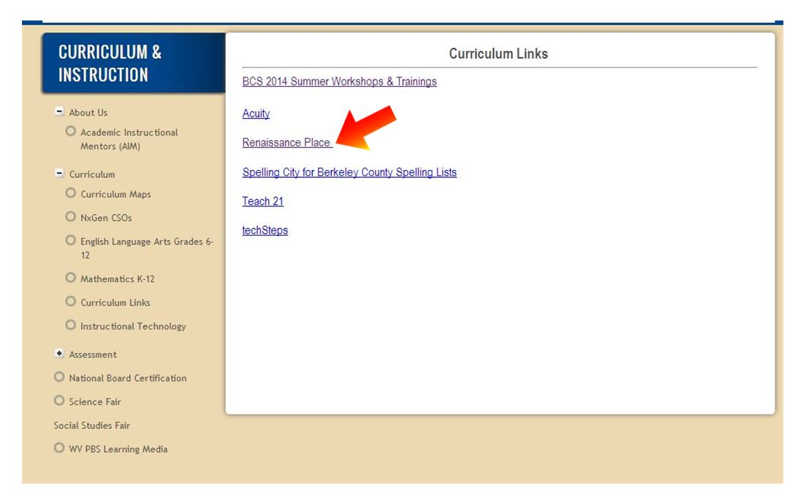3.

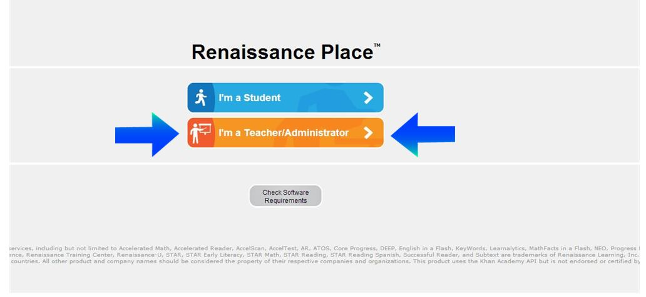4.

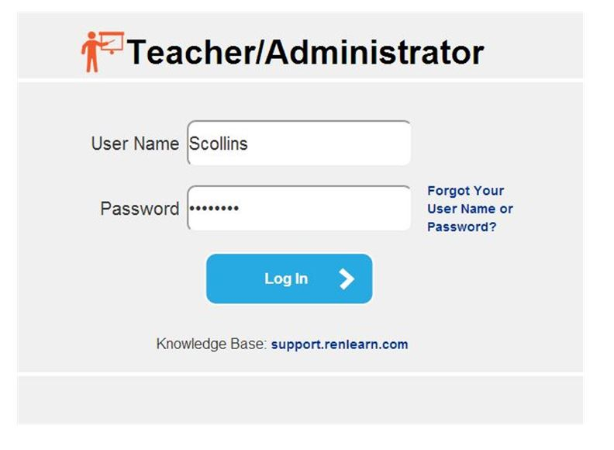5.

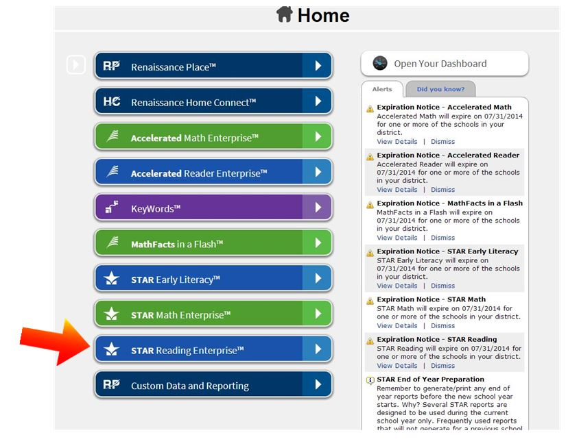

6.

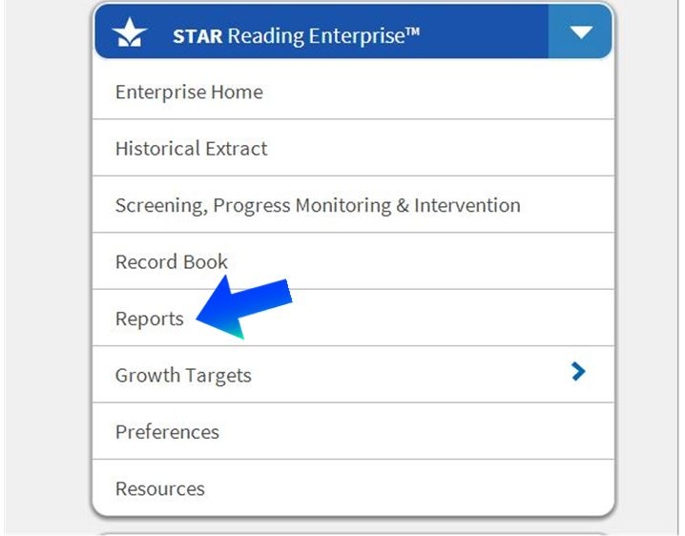7.

8. Instructional Planning – Class

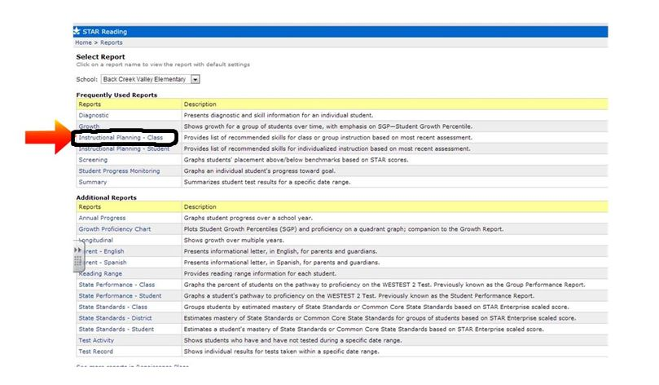

**Instructional Planning – Class Report**

**-**provides list of recommended skills for class or group instruction based on most recent assessment

-ranks students by scaled score and percentile rank

-tool to aide in forming flexible guided reading groups

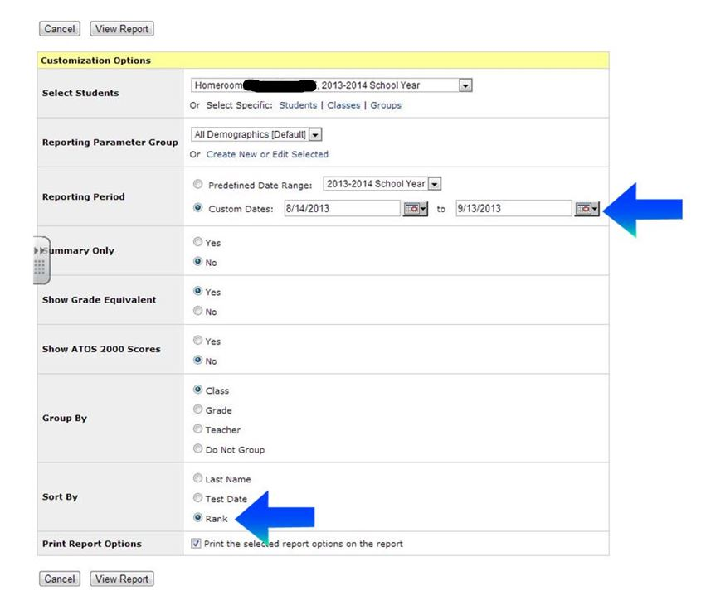 9.

**Dates**

**Sort by Rank**

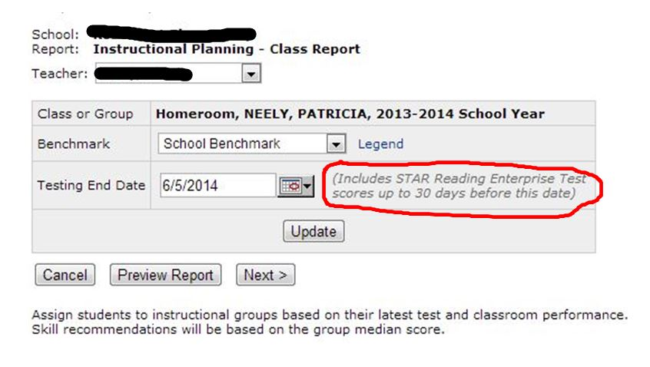10.

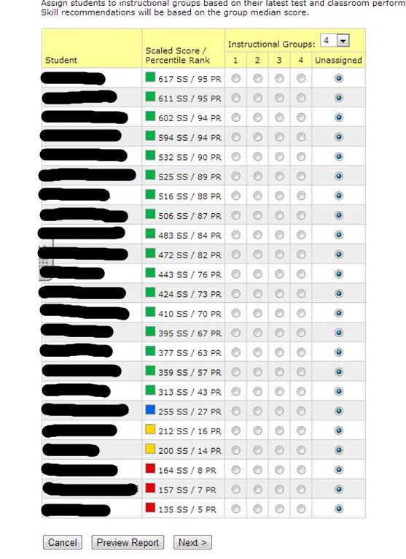11.

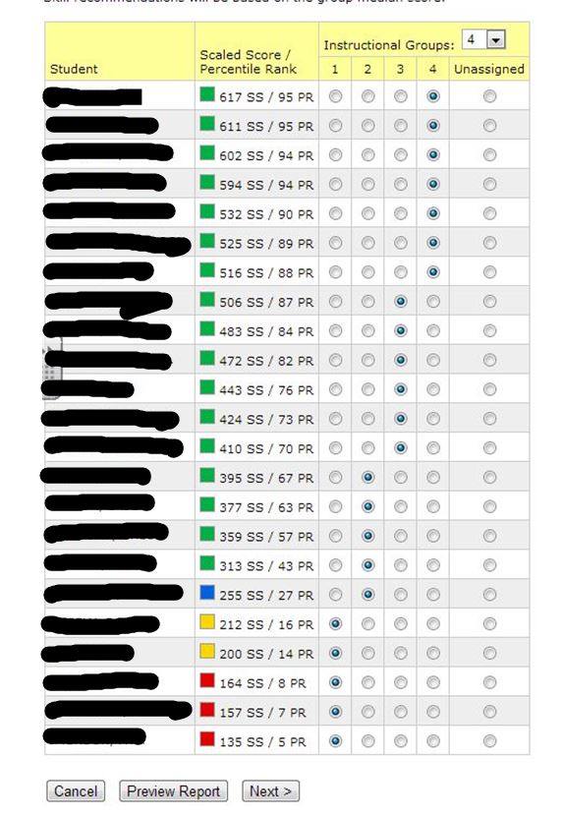12.

13. **Report of recommonded skills for each group**

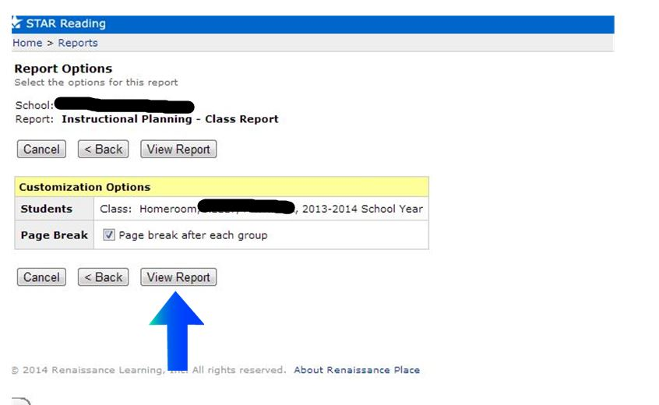

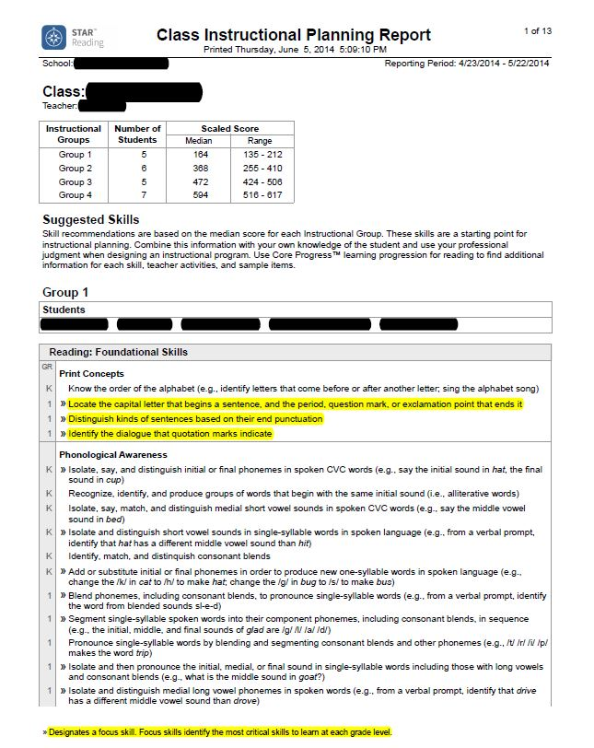

14.

15. Summary Report (for students’ Independent Reading Level)

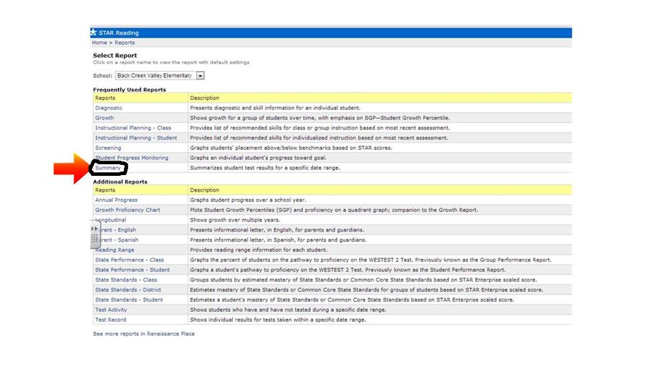

**Summary Report**

**-**to obtain students’ independent reading level

-tool to aide in building individual book bins/bags/boxes for your students

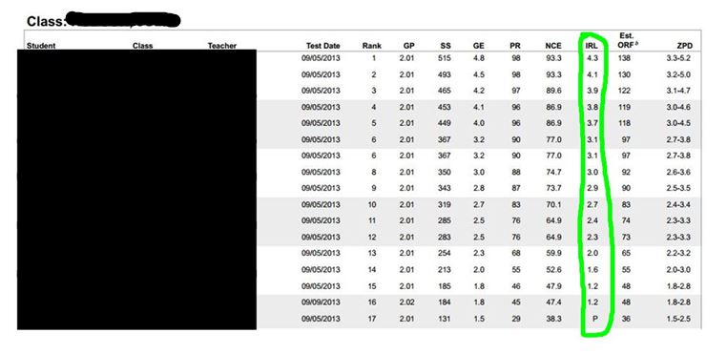16.